[Capgemini : Consulting, Technology, Outsourcing](http://www.capgemini.com/) 

Statoil Learning Center

User Guide

TABLE OF CONTENTS

1 Document Purpose 3

2 Scope 3

3 Target Audience 3

4 Access Level 3

5 Overview 4

5.1 Accessing Statoil Learning Center 4

5.2 Learning & Development 5

5.3 Team Book 12

5.4 Events 14

Appendix 15

THIS DOCUMENT contains 15 pages including title page

**Disclaimer**

No part of this publication may be reproduced in any form, in an electronic retrieval system or otherwise, without the prior written permission of the publisher. Material contained herein is reserved for members of Capgemini and therefore is not to be quoted, cited or shown external to the Capgemini companies without their written permission.

# Document Purpose

The purpose of this document is to provide you a step-by-step guide through the learning opportunities available in Statoil Learning Center (SLC). It will also suggest guidelines on using the key functionalities of the SLC.

SLC will guide employees of the Capgemini Statoil Engagement to a focused learning environment through learning modules. Through SLC, the progress of each learning can be tracked real-time.

# Scope

At the end of this document, an end user can perform the following:

As a **User**: Navigate the site, find documents, undergo online training and know more about Statoil Engagement.

# Target Audience

This document is intended for all service delivery personnel working for the Statoil Engagement.

# Access Level

The permission levels assigned to the users and SDM/TSM/Leads is as follows:

**Resource Group/SDM/TSM/Leads**: Contribute access

**PMO**: Full access to all the links on the SLC

# Overview

Statoil Learning Center is an internal web-based learning management system developed toenhance growth and development of its most valuable resource, its people, and create a continuous learning environment. The portal helps deliver and manage learning content for new joiners as well as existing employees. It provides the tools necessary to manage training schedule, and track professional growth of its service delivery personnel.

## Accessing Statoil Learning Center

1. Open your Internet browser and go to <https://troomx.capgemini.com/sites/statoil_ls/SitePages/Home.aspx>.
2. The Statoil Learning Center home page screen will appear:

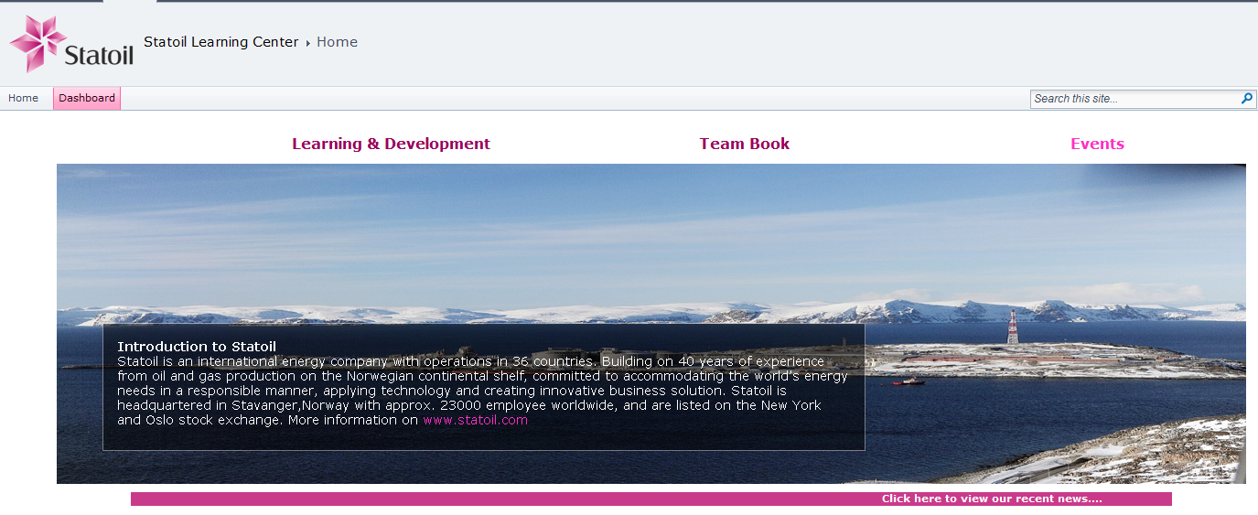

* **Home**: Click the Home tab to return to the SLC home page.
* **Dashboard/Incomplete Training**: The Dashboard and incomplete training has restricted access only to PMO team and SDM/TSM/Leads.

The SLC home page consists of three main functional tabs:

* **Learning & Development**: Contains all the learning modules that the new joiners have to undergo to complete onboarding sessions.
* **Team Book**: Illustrates the Organisation Chart of the Statoil Engagement.
* **Events**: Latest news and announcements on the team.

## Learning & Development

### Overview

Learning & Development is about enabling all individuals to successfully achieve future goals. Your ongoing professional development is of critical importance to the Statoil Engagement, and it will become an important part of your working life during your stay here.

This section consists of various knowledge areas, phases and information resources pertaining to Statoil Engagement. Each phase has different learning modes such as Instructor-led training, online training (through links, PowerPoint Presentations, Word Documents, etc.) and virtual training.

Each learning area is designed to help you gain a better understanding of Statoil products and services and use them more effectively to meet your business requirements.

We have identified and defined seven learning areas:

* Welcome to Statoil
* Know Statoil
* E- Learning
* Know Capgemini
* Delivery Agreements
* ITIL
* Tools

**Note**: All knowledge areas leading to Statoil links require login credentials.

### Learning & Development Home Page

1. Click the Learning and Development tab on the Statoil Leaning Center home page. The following screen will appear.

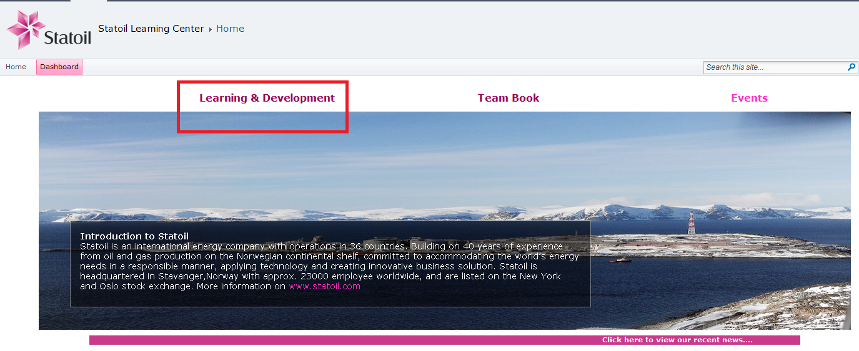

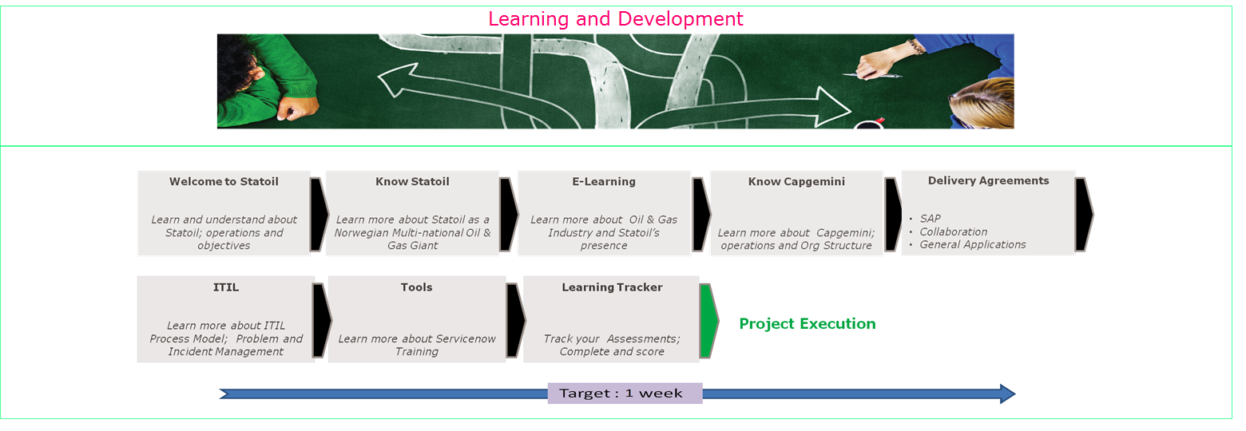

#### Welcome to Statoil

On completion of this module, you will gain knowledge into Statoil’s core Objectives and Operations.

The Welcome to Statoil section consists of two knowledge areas each comprising one module:

* Statoil Onboarding
* Statoil Offboarding

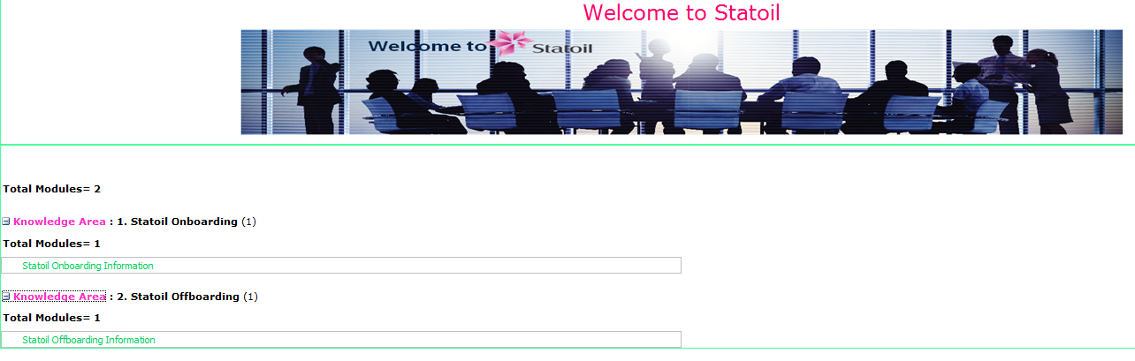

#### Know Statoil

This module talks about Statoil’s prowess as a Norwegian multinational Oil and Gas giant that is headquartered in Stavanger, Norway.

The Know Statoil section consists of five knowledge areas:

* Industry
* Organisation
* Values and Management
* How we work – Process Areas
* How we work – Function Areas
* How we work – Business Areas
* HSE

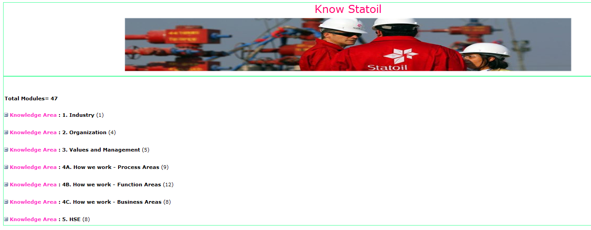

#### E- Learning

**Page under construction. More details to follow**



#### Know Capgemini

This section provides information related to the Capgemini Group, its governance structure and operations.

The **Know Capgemini** section consists of four knowledge areas:

* Organisation
* Values and Management
* HSE
* Cross-cultural

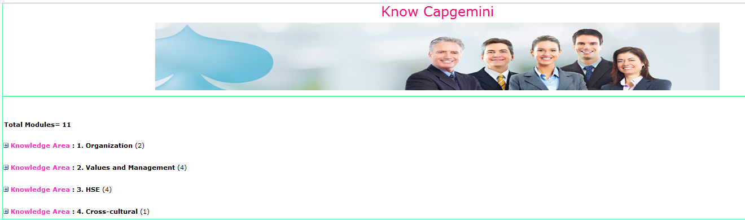

#### Delivery Agreements

SAP, Collaboration and General Application

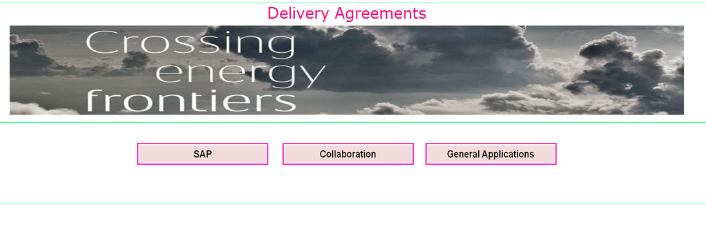

The Delivery Agreements section covers the three towers of the Statoil Engagement.

**Note**: You need to complete only the topics covered under your Delivery Agreement.

1. **SAP** covers the following knowledge areas:

* Scope of Services
* Organizational Structure
* Procedure Manual
* Service Level Requirements and KPIs
* Business Process
* Supply Chain Management
* Sales & Distribution
* Plant Operation and Maintenance
* HR
* Business Warehousing
* Across System PI
* Across System MDM
* Across System GRC
* Across System Basis
* Across System ABAP
* Across System ABAP - Cross Operations Monitoring
* Accounting & Control
* Treasury & Payment

1. **Collaboration** covers the following knowledge areas:

* Scope of Services
* Organizational Structure
* Procedure Manual
* Service Level Requirements and KPIs
* Business Process
* IT Messaging
* IT-Content and Record Services
* Topcall
* IBM-Content Manager
* Kofax
* IT-BPM
* IT-SharePoint Services - AOD
* IT-Shared Applications
* Office Applications
* IT-Information Management - Sharepoint + G drive
* Metadata
* IT Integration – SSIS
* Biztalk
* Websphere MQ
* Suresync

1. **General Applications** covers the following knowledge areas:

* Scope of Services
* Organizational Structure
* Procedure Manual ‎
* Service Level Requirements and KPIs
* Business Process
* Technical Documentation
* System Documents
* CCURE

#### ITIL

This section gives a brief overview about the ITIL process model covering the ITIL lifecycle - Incident, Problem, Change and Knowledge Management

The ITIL section consists of one knowledge area:

* **Common Documents**: Each module contains technical documents relating to Incident, Problem, Change and Knowledge Management.

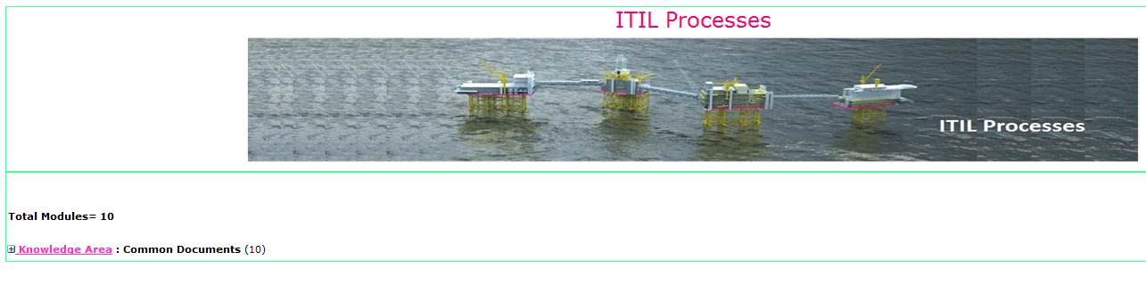

#### Tools

The Tools section consists of one knowledge area:

* This module provides links to formal training relating to ServiceNow tool has been developed by Statoil.

#### Learning Tracker

Track your assessments, Complete and Score

This is designed to provide real-time information and status for all the onboarded resources and ensure the learning objectives are met. It shows you the completion percentage, status and due date of the learning courses.

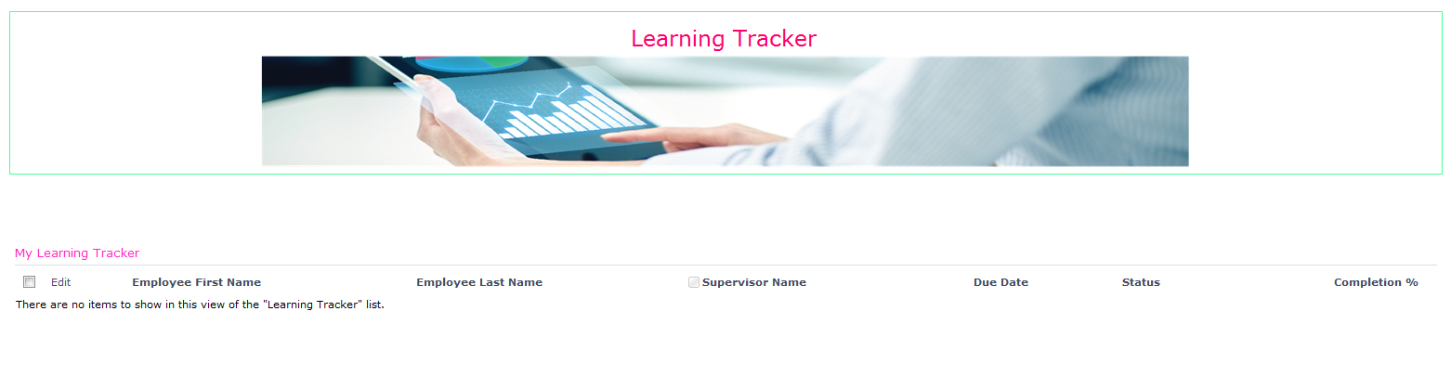

Updating Learning Tracker

Learning tracker helps you to update and track your learning modules. Once a resource is onboarded, an email is triggered to the individual assigning a due date for completion of the learning area/phases/modules.

The employee receives an email with the link to the learning tracker.

1. Open the learning tracker and select the learning area that you have completed.
2. Click the **Save** button.

**Notes:**

1. The learning tracker has to be updated by the employee, each time he/she completes a learning session.
2. If all the learning modules are not completed within a week of assigning; a reminder email will be sent to the employee.
3. Once, the learning modules are complete, an email is triggered to the employee’s supervisor marking the employee. The supervisor must acknowledge the email. If not, another reminder mail will be sent to the supervisor.

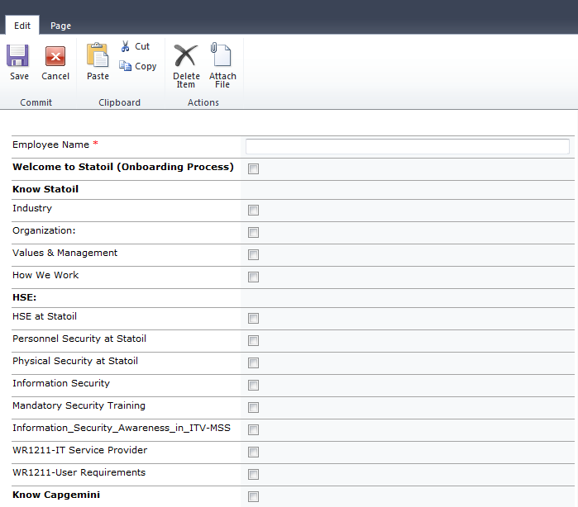

## Team Book

The team book home page illustrates the typical hierarchical arrangement of lines of authority, communications, rights and duties of the three towers in the Statoil Engagement.



Each tower is further sub-categorized to show the entire engagement’s governance structure.

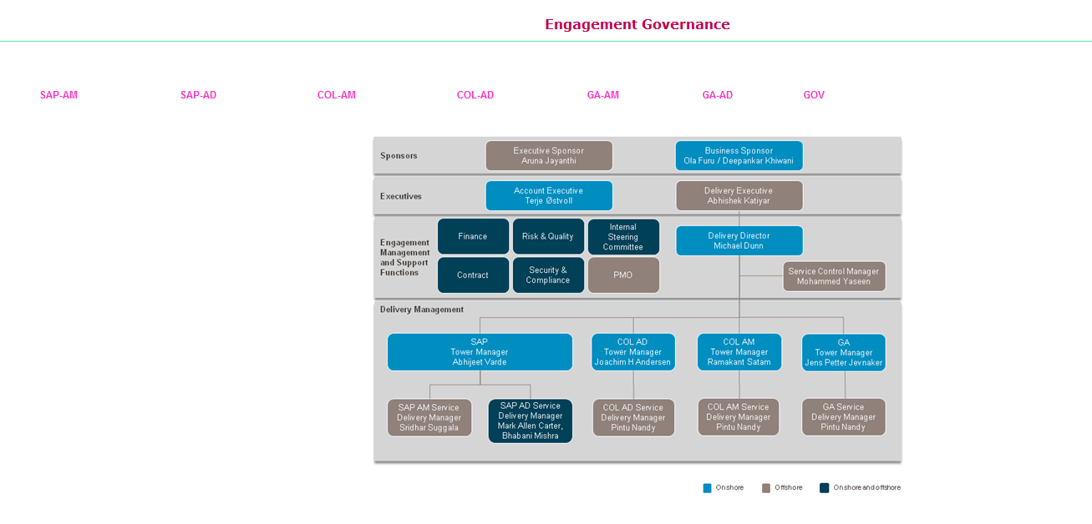

Updating Statoil Team Book

An auto generated mail is triggered to the new joiners mailbox; requesting them to update their details on the team book page.

**Note**: You must update your personal details along with previous experience, hobbies and other details in the team book.

1. Enter employee name in the **Name** field.
2. Select **Role, Location and Manager** from the respective dropdowns.
3. Enter data in the all the other fields as shown in the below screenshot.
4. Click **Save** to save your details.

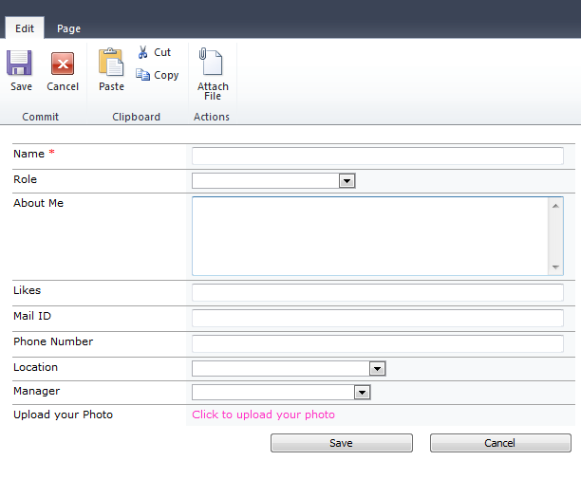

**Note**: Steps to upload your photo.



## Events

This page shows news and announcements made to the team.

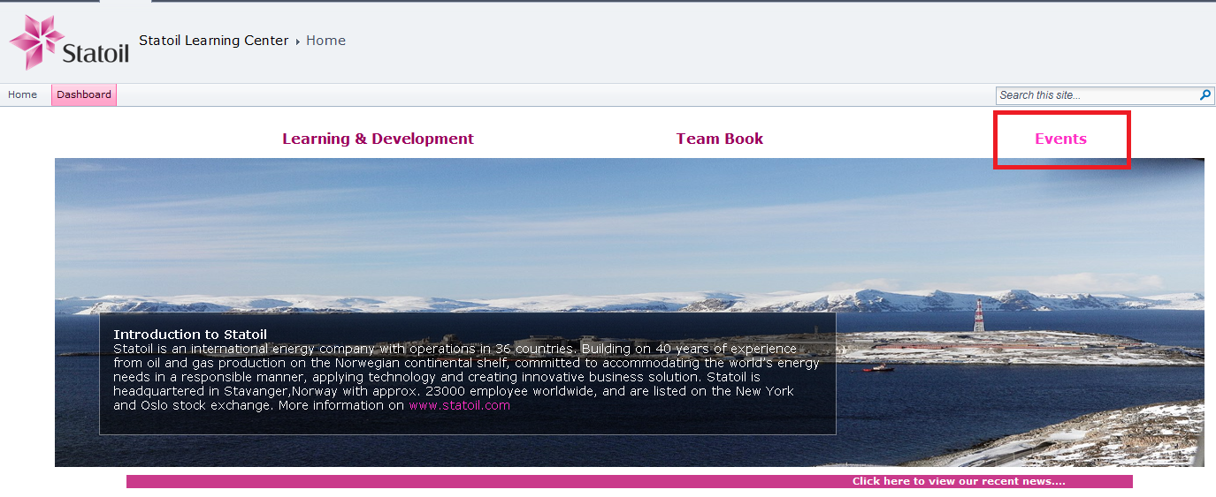

Appendix

Acronyms and Abbreviations

The following acronyms and abbreviations are used in this document:

|  |  |
| --- | --- |
| Acronyms and Abbreviations | Expansion |
| DA | Delivery Agreement |
| L&D | Learning and Development |
| PMO | Project Management Office |
| SDM | Service Delivery Manager |
| SLA | Service Level Agreement |
| SLC | Statoil Learning Center |
| TSM | Tower Service Manager |

**END OF THE DOCUMENT**